THE KING IS COMING!!
(Vs. 7) Behold, he is coming with the clouds,

(Acts 1:9-11 NIV) “After he (Jesus) said this, he was taken up before their very eyes, and a cloud hid him from their sight. They were looking intently up into the sky as he was going, when suddenly two men (angels) dressed in white stood beside them. Men of Galilee, they said, Why do you stand here looking into the sky? This same Jesus, who has been taken from you into heaven, will come back in the same way you have seen him go into heaven.”

(vs. 7-8) “and every eye will see him, even those who pierced him, and all tribes of the earth will wail^{[b]} on account of him. Even so. Amen. ⁸ “I am the Alpha and the Omega,” says the Lord God, “who is and who was and who is to come, the Almighty.”

He Is Coming!!

A. A _____________ Coming

B. A ______________ Coming

C. A Victorious __________________________

He Is
- _________________________
- ______________________________________________________________________________________________________
- _________________________
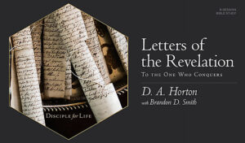
Sign up for the Bible Study: Letters of the Revelation
on our website:
www.newhopecamden.com

Sermon Notes September 27, 2020
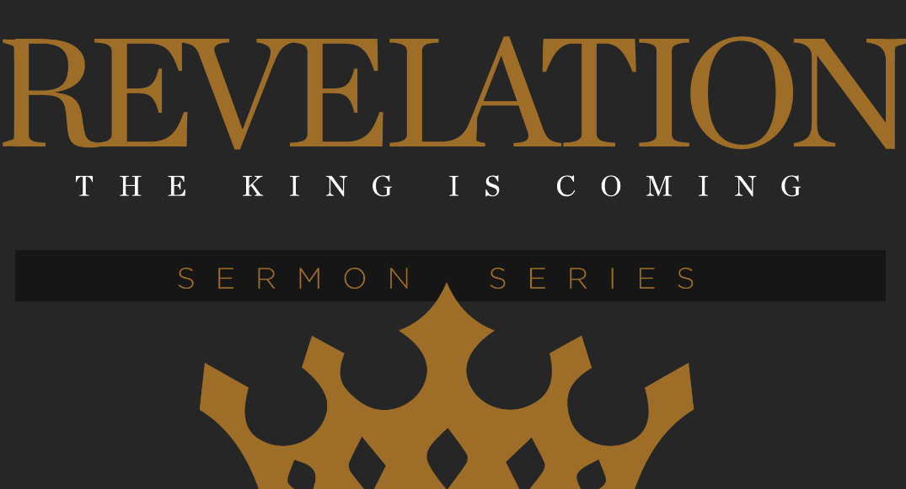

Give online at: www.newhopecamden.com/tithe
The King Is Coming

Revelation 1:1-8 (ESV) The revelation of Jesus Christ, which God gave him to show to his servants the things that must soon take place. He made it known by sending his angel to his servant John, ² who bore witness to the word of God and to the testimony of Jesus Christ, even to all that he saw. ³ Blessed is the one who reads aloud the words of this prophecy, and blessed are those who hear, and who keep what is written in it, for the time is near. ⁴ John to the seven churches that are in Asia: Grace to you and peace from him who is and who was and who is to come, and from the seven spirits who are before his throne, ⁵ and from Jesus Christ the faithful witness, the firstborn of the dead, and the ruler of kings on earth. To him who loves us and has freed us from our sins by his blood ⁶ and made us a kingdom, priests to his God and Father, to him be glory and dominion forever and ever. Amen. ⁷ Behold, he is coming with the clouds, and every eye will see him, even those who pierced him, and all tribes of the earth will wail on account of him. Even so. Amen. ⁸ “I am the Alpha and the Omega,” says the Lord God, “who is and who was and who is to come, the Almighty.”

INTRODUCTION
______________ is the Author

I. IDENTIFYING MARKS

A. The Subject of the Book is ______________________________________
(vs. 1) the revelation of Jesus Christ
Revelation is the Greek word apocalypses which literally means
an ______________ or an ______________

B. The Source of the Book is ___________________________
(vs.1) …which God gave him….

C. Written for His _______________
(vs.1) …to show his servants….

D. The Symbols
(vs.1) …. He made it known (signified – NAS) by sending his angel…
Symbolic language gives literal ________________
II.THE INVOCATION
(Vs. 3) Blessed is the one who reads aloud the words of this prophecy, and blessed are those who hear, and who keep what is written in it, for the time is near.
Rev. 22:7 – Look, I Am coming soon! Blessed is the one who keeps the word’s of the prophecy written in this scroll.

A Blessing to those who . . .
- _________________
- _________________
- _________________
III. A TRINITARIAN BENEDICTION
(vs. 4) John to the seven churches that are in Asia: Grace to you and peace from him who is and who was and who is to come, and from the seven spirits who are before his throne, ⁵ and from Jesus Christ the faithful witness, the firstborn of the dead, and the ruler of kings on earth. To him who loves us and has freed us from our sins by his blood ⁶ and made us a kingdom, priests to his God and Father, to him be glory and dominion forever and ever. Amen.

- There is a greeting from God the Father
- There is a greeting from God the Holy Spirit
- There is a greeting from God the Son

A. He is the _____________________ Lord – “faithful witness”

B. He is the ______________________ Lord – “the firstborn of the dead”

C. He is the ____________________ Lord – “the ruler of kings”

D. He is the ______________________ Lord

- He ___________ us
- He ____________us
- He ____________ us
E. He is the ____________________ Lord – “to him be glory and dominion forever and ever. Amen.”

